DIS-Clovis Flint Core-Big Muddy Creek-Utah

# Clovis Flint Core, San Rafael Swell, Emory County, Utah

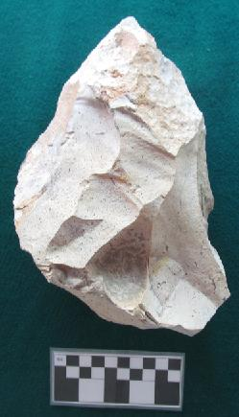 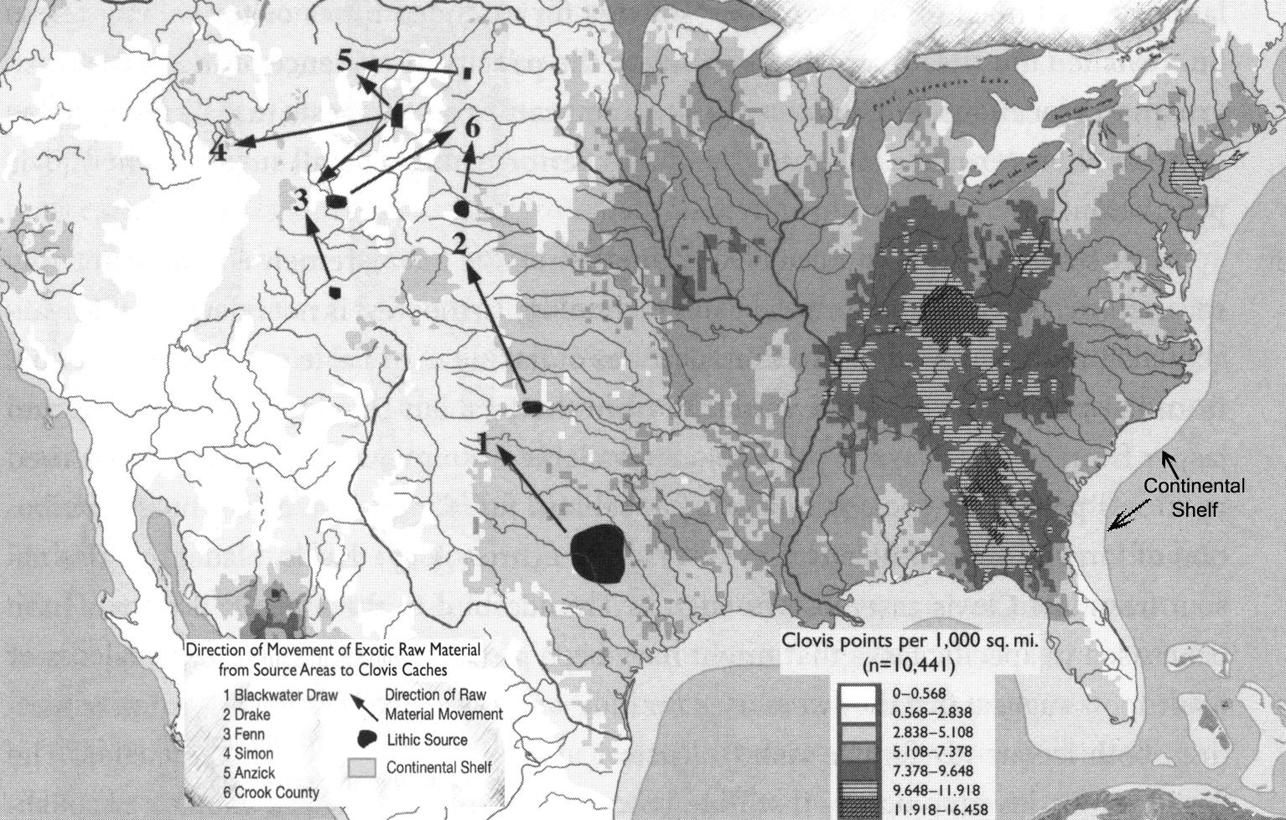

Fig. 1: Clovis Techno -Complex flint core. Fig. 2: Distribution of "Clovis points per 1,000 sq. mi." in North America and "Direction of Movement of Exotic Raw Material from Source Area to Clovis Caches" (after Stanford and Bradley 2012, p. 40, Fig. 2.4).

This Clovis Techno -Complex flint core is from the vicinity of the Molen Reef, San Rafael Swell, Emory County, Utah, which is comprised of rusty sandstone, mixed with shale, siltstone, and limestone dating to the Cretaceous and Jurassic periods (See Bradley et al. 2010, Plates 2-3). Because this core is of a high quality flint which is not found in the Molen Reef area, it was probably imported by mobile Paleolithic hunter gatherers from a flint source similar if not identical to that of the Fenn cache from southeastern Utah (See Fig. 2, no. 3, Fenn cache, Crook County).

Blanks were struck off this core to produce distinctive Clovis fluted projectile points which date from ca. 11,000 BCE to ca. 7,000 BCE and were developed to hunt large mega-fauna such as the mammoth, the mastodon and the archaic bison in North America using an atlatl or throwing stick. The highest concentrations of Clovis points stretch along a mid-Atlantic band extending south from Post Algonquin Lake (what later became the Great Lakes) to the Gulf of Mexico (See Fig. 2 above.

Also in the area where this core was found are the Rochester Creek petroglyphs which may be associated with the Fremont culture (ca. 1-1300 CE) which, based on its late dates, have no association the Clovis Techno -Complex.